**Tamil Nadu**

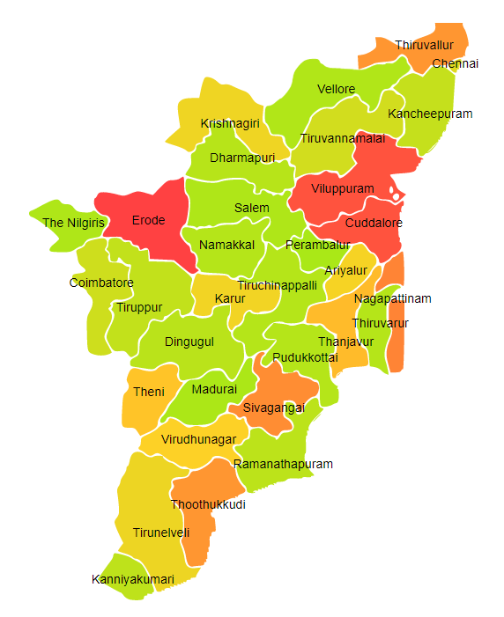

Tamil Nadu comprises of three Agro Ecological Regions (AER) 8,18 & 19.

**Agro-Eco Region 8:** AER 8 in Tamil Nadu comprises of Ariyalur, Coimbatore, Cuddalore, Dharampuri, Dindigul, Erode, Kanyakumari, Kanchipuram, Karur, Krishnagiri, Madurai, Namakkal, Perambalur, Pudukkottai, Ramanathapuram, Salem, Sivaganga, Teni, Thanjavur, Tirunelveli, Tiruppur, Tiruchirappalli, Tiruvallur, Tiruvannamalai, Tuticorin, Vellore, Villupuram and Virudhunagar districts of Eastern Ghats under Agro Ecological Sub Regions (AESR) 8.1,8.2 & 8.3.

**Agro-Eco Region 18:** AER 18 in Tamil Nadu comprises of Chennai, Nagapattinam, Ramanathapuram, Thiruvarur, Cuddalore, Kanchipuram and Tiruvallur districts of Eastern Coastal Plain under Agro Ecological Sub Regions (AESR)18.1 &18.2 .

**Agro-Eco Region 19:** AER 19 in Tamil Nadu comprises of Coimbatore, Kanyakumari and Nilgiri districts of Western Ghats & Coastal Plain under Agro Ecological Sub Regions (AESR)19.2 & 19.3.